Real World Impact: Resilience for a Changing Climate (14 point bold)

Isaree Apinya¹ and Nattakarn Ratchakun^{2,*}
(11 point bold)

¹Faculty of Environment and Resource Studies, Mahidol University, Nakhon Pathom 73170, Thailand
²Faculty of Science, Mahidol University, Nakhon Pathom 73170, Thailand (9 point italic)
*Corresponding Author E-mail:………………………..

ABSTRACT (12 point bold)

In the last two decades, the challenges from environmental catastrophes have become greater than ever. Global warming and climate change are causing devastating impacts around the world. The frequency and severity of natural disasters are rapidly increasing; man-made pollution is threatening the safety of the food we eat, water we drink and air we breathe; current agriculture and aquaculture methods are decimating our natural resources. Innovations and sustainable technologies are needed to reduce environmental degradation and improve sustainability. The principle of sustainability is emerging as a global concept that requires research and development of ideas from a broad range of sciences and practices. A healthy environment and sustainable use of our natural resources are essential for the peace and security of future mankind. Transforming from current knowledge platforms towards sustainable paradigms should be initiated with appropriate solutions that will take careful planning and consideration. The goal is to conserve natural resources and improve the economic viability of human livelihoods. Protection and conservation of land, water, biodiversity and climate are pre-requisite to saving our future earth in a sustainable way. Building strong engagement is critical for communicating, evaluating and implementing complex innovations to replace traditional economic and social interacting systems. With this goal, we propose to hold the 4th Environment and Natural Resources International Conference as a Virtual Format due to the Coronavirus (COVID-19) situation. We welcome researchers to present their work related to environmental issues and discuss the challenges facing our future global safety, security and sustainability. (10 point)

Keyword: Engineering/ Environment/ Natural resources/ Sustainable development (10 point)

1. INTRODUCTION (12 point bold)
The Environment and Natural Resources Journal has been published since 2001 by the Faculty of Environment and Resource Studies, Mahidol University, Thailand. Environment and Natural Resources is an open access journal and international publication devoted to various disciplines in environmental science and technology [1]. The journal aims to provide the most complete, up-to-date, and reliable sources of information on current developments in the field of environment and natural resource studies with an emphasis on publishing quality articles promptly and making them freely available worldwide. (11 point)

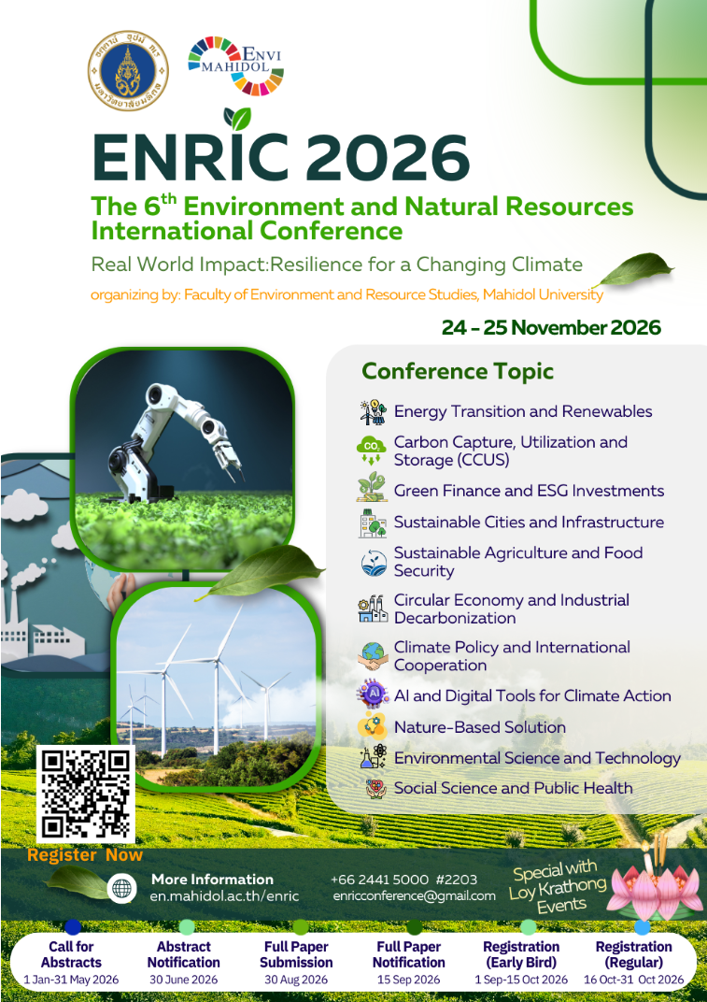

Figure 1. Poster of ENRIC conference (9 point) [The images require a resolution of at least 600 dpi. (dots per inch)]

2. METHODOLOGY (12 point bold)
2.1 XXXXX (11 point bold and italic)
The Environment and Natural Resources Journal has been published since 2001 by the Faculty of Environment and Resource Studies, Mahidol University, Thailand. Environment and Natural Resources is an open access journal and international publication devoted to various disciplines in environmental science and technology [2]. The journal aims to provide the most complete, up-to-date, and reliable sources of information on current developments in the field of environment and natural resource studies with an emphasis on publishing quality articles promptly and making them freely available worldwide. (11 point)

2.2 YYYYY

3. RESULTS AND DISCUSSION (12 point bold)
3.1 XXXX (11 point bold and italic)
It is our honor and great pleasure to invite all to attend this 4th Environment and Natural Resource International Conference (ENRIC). The target groups for this International Conference are students, researchers, academicians, scientists, engineers, NGO members, policy makers and other stakeholders from the fields of science, engineering, environment, natural resources, and sustainable development. (11 point)

3.2 YYYY

4. CONCLUSIONS (12 point bold)
Based on laboratory experiments and data analysis in this study. Some conclusions were drawn as follows:
1. To gather researchers in environmental science and other disciplines related to environment and natural resources issues, so that they may present their recent research findings and achievements.
2. To share current research and management experience amongst the university community, consulting and governmental agency professionals, and environmental organizations.

3. To stimulate the development of collaborative research on environment and natural resources issues in the S.E.A. region. (11 point)

Acknowledgement (12 point bold)
The authors acknowledge the ……………. (11 point)

References (12 point bold) (In the list of references at the end of the manuscript, full and complete references must be given in the following style and punctuation)

(Reference must be given in APA style. Use a sequential number system for references and use 9 point for font size in the reference lists)
[1] Ali, M., Jiang, R., Ma, H., Pan, H., Abbas, K., Ashraf, U., & Ullah, J. (2021). Machine learning-A novel approach of well logs similarity based on synchronization measures to predict shear sonic logs. Journal of Petroleum Science and Engineering, 203, 108602.
[2] Anees, A., Wanzhong, S., Ashraf, U., Qinghai, X. (2019). Channel identification using 3D seismic attributes in lower Shihezi Formation of Hangjinqi area, northern Ordos Basin, China. Journal of Apply Geophysics, 63, 139-150.
[3] Ashraf, U., Zhang, H., Anees, A., Mangi, H. N., Ali, M., Zhang, X., Imraz, M., Abbasi, S., Abbas, A., Ullah, Z., and Tan, S. (2021). A Core Logging, Machine Learning and Geostatistical Modeling Interactive Approach for Subsurface Imaging of Lenticular Geobodies in a Clastic Depositional System, SE Pakistan. Natural Resources Research, 30, 2087-2830.
[4] Ashraf, U., Zhu, P., Yasin, Q., Anees, A., Imraz, M., Mangi, H. N., & Shakeel, S. (2019). Classification of reservoir facies using well log and 3D seismic attributes for prospect evaluation and field development: A case study of Sawan gas field, Pakistan. Journal of Petroleum Science and Engineering, 175, 338-351.
[5] Bunopas, S., and Vella, P. (1983). Opening of the gulf of Thailand: rifting of continental S.E. Asia and Late Cenozoic Tectonics; Journal of Geological Society. Thailand, 6, 1-12.

